2023

kintu

5/16/2023

The African climate

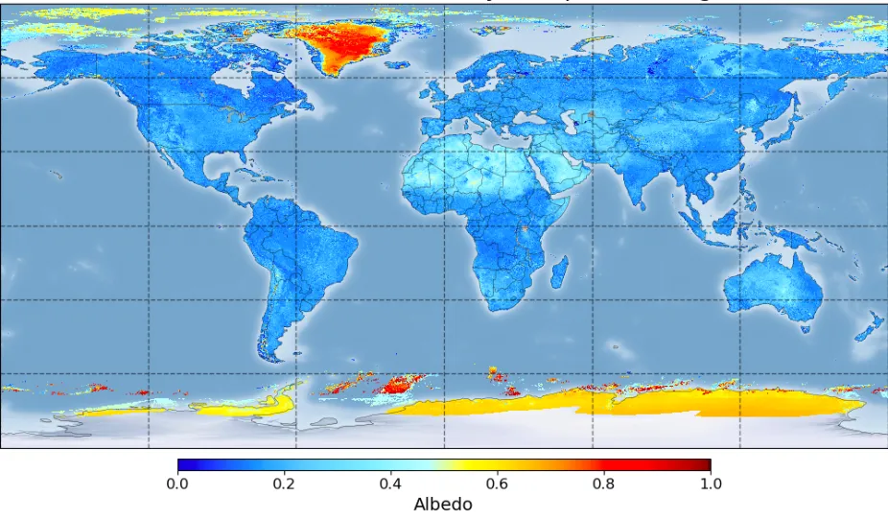

Climate of Africa

Climate is the state of the average weather conditions of a given place recorded over a

long period of time usually about 35 years and above.

Climate of a place is determined when the elements of weather like rainfall and temperature are measured and recorded for a long period of time - 35 years.

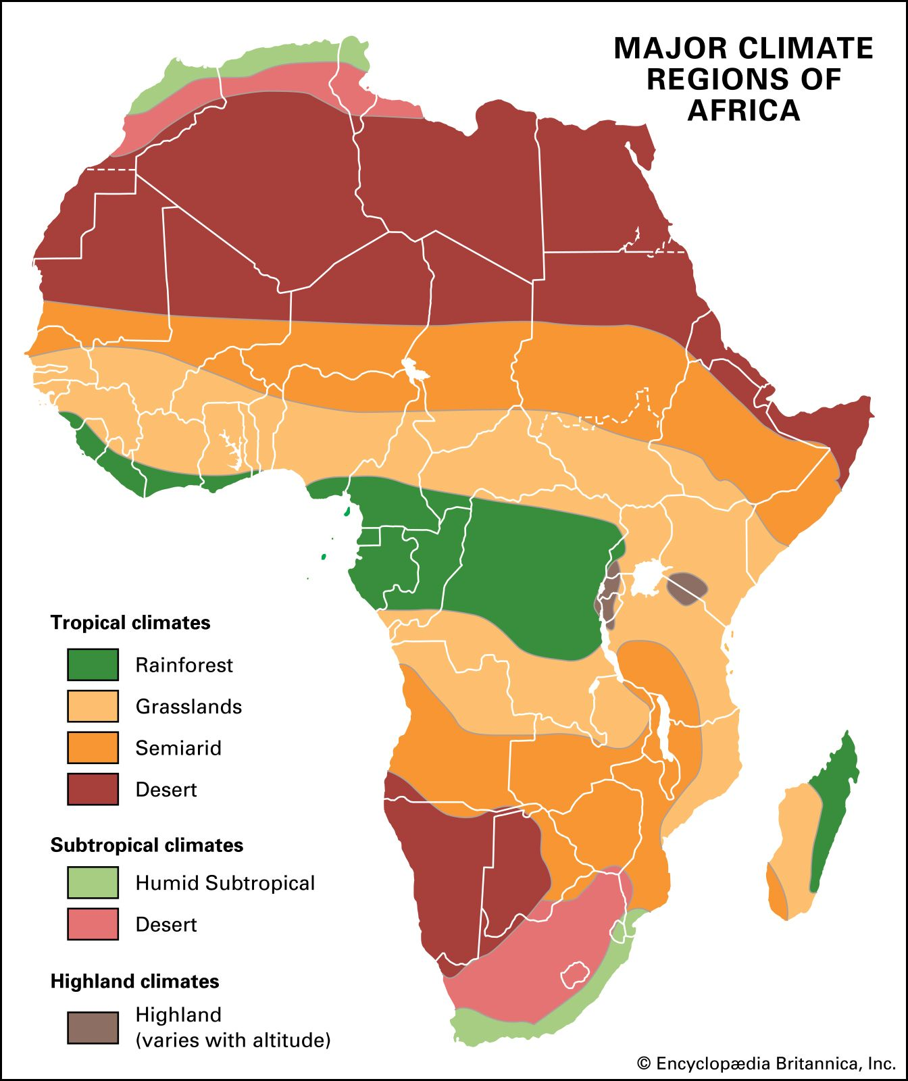

In Africa, climate experienced is mainly hot and wet although there are some place experience different types of climates like semi desert climate, hot desert climate as well as temperate climate in highland areas.

## The Types of climates

Arica has the following general types of climates:

* Equatorial climate
* Savanna climate/tropical continental/Sudan type of climate
* Tropical Semi-arid climate
* Desert climate
* Montane/ mountain climate
* Mediterranean
* East margin

# Equatorial climate

## Location:

It is mainly found between 50 North and South of Equator, but extend to 100 north and south of 00.

* It is well developed in central Africa, West Africa in the southern Ghana, southern parts of Nigeria, Cameroon, Gabon, Republic of Congo, Democratic Republic of Congo, Guinea, southern Ivory Coast, east coast of coastal Malagasy Republic and east African highlands. It is characterized by the following:
* It has uniformly warm to hot temperatures of about 260C, small (low) annual range of about 20C to 30c, and small diurnal range of 10c to 80c. The temperature ranges between 220c - 290c.
* Heavy and well distributed rainfall throughout the year with a double maxima/two peaks of rainfall: march-may (long rains) and October- November (short rains) and April is the wettest month
* The rainfall is normally conventional type of rainfall from towering cumulonimbus clouds, accompanied by thunderstorms and lightening; and rainfall occurs in the afternoons and evenings.
* Humidity is very high throughout the year and relative humidity is constantly high over 80%.
* Heavy clouds cover throughout the year.
* The sun rising is between 6:00am and 6:30am and setting is between 6:00pm-6:30pm (almost equal).
* The mid-day sun is always near vertical and overhead twice a year at the equinoxes.
* Morning weather is often quite sunny and clear, but heat builds up during the day until by about 2.00pm. Cumulus clouds develop growing into towering Cumulo nimbus which gives heavy rain.
* There is little or no dry season.

Summary: Hot and wet throughout the year.

## Factors that lead to equatorial climate

* Proximity to large water bodies that fill the atmosphere with moisture and then results to rainfall
* Proximity to the equator that results into the rainfall formation
* The conversion of the south east trading winds with the north west trading winds that lead to the rainfall formation
* Nearness t the equator which results to the hot temperature
* The dense tropical forests in the tropics that support the formation of rainfall due to the high evaporation rate and this increases the humidity
* The movement of the sun that results to the high rainfall rate and the high humidity and temperatures

## Economic activities carried out in this type of climate

* Growing of perennial corps due to the heavy rainfall received like bananas in DRC, coffee in Uganda and cloves in Madagascar
* Plantation agriculture is also carried out due to heavy rainfall received such as rubber plantations in Liberia tea in Uganda cocoa in Nigeria
* Lumbering due to the large number of rainforests and conditions that favour their growth
* Tourism due to the tropical rainforests and their animals like elephants and monkeys and bird and lions, gorillas
* Industrialization like palm oil processing and fruit processing factory and the agro-processing industries
* Wild-life conservation in game parks and reserves because there is natural habitat for these animals
* fishing activities due to the numerous rivers e.g., Congo, R.Niger, R.Nile , R.Volta among others
* trade and commerce due to a variety of crops and timber from forests
* mining because these areas have numerous minerals like bauxite and gold in Ghana, oil in Nigeria and Uganda, copper in DRC, Uganda and Zambia

## problems faced by people living in this climate

* the humid climate favours the multiplication of various pests and diseases which attack man his animals and crops like mosquitoes that spared malaria
* the dense equatorial forests make the construction of transport routes difficult which leads to remoteness
* soil leaching due to heavy rainfall which reduces soil fertility thus affecting agriculture
* soil erosion by running water due to heavy rainfall received in the equatorial regions which leads to the loss of soil fertility
* attacks from wild animals that risks peoples lives
* flooding due to heavy rainfall that cuts off transport lines and destroys properties and lives and spread of water borne diseases
* lightening and thunderstorms which leads to loss of lives and property
* land slides in the highland areas and mud slides in the flat areas that wipe out entire settlements

Activity: Study the climate figures below answer the questions that follow:

Libreville- Gabon coast

|  |  |  |  |  |  |  |  |  |  |  |  |  |
| --- | --- | --- | --- | --- | --- | --- | --- | --- | --- | --- | --- | --- |
| Month | Jan | Feb | Mar | April | May | June | July | Aug | Sept | Oct | Nov | Dec |
| Temp [0C] | 30 | 31 | 31 | 31 | 30 | 29 | 28 | 28 | 29 | 29 | 29 | 30 |
| Rain [mm] | 250 | 250 | 325 | 300 | 213 | 25 | 25 | 25 | 100 | 275 | 380 | 200 |

Freetown: Sierra Leone coast

|  |  |  |  |  |  |  |  |  |  |  |  |  |
| --- | --- | --- | --- | --- | --- | --- | --- | --- | --- | --- | --- | --- |
| Month | Jan | Feb | Mar | April | May | June | July | Aug | Sept | Oct | Nov | Dec |
| Temp [0C] | 30 | 31 | 31 | 30 | 29 | 28 | 27 | 27 | 28 | 29 | 30 | 30 |
| Rain [mm] | 25 | 25 | 50 | 100 | 275 | 500 | 900 | 925 | 700 | 300 | 125 | 25 |

Activity:

* Draw suitable graph to represent the information in the table for Libreville.
* Describe the characteristics of climate of Libreville.

Hint 1: How to draw graph climate graphs:

* The vertical axis should be labeled ‘rainfall in mm’, temperature in 0c and the horizontal axis ‘months of the year’
* Use the space on the graph profitably by drawing an appropriate graph. Remember that all the information [tittle, scale, labeling of the horizontal and vertical lines] should fit on the graph paper.
* On top of the axis for rainfall add another for temperatures. Label its Degrees centigrade.
* Use appropriate scale to draw the climatic graph. A suitable scale is 1cm for 5 degrees centigrade. State that 1cm represents 5 degrees centigrade of temperature. If you make a big scale the temperature graph will be exaggerated and misleading. The line graph tends to suggest high range of temperature which may not be the case.
* Use a line graph for temperature graph. Plot neat points/dots in the right locations and join them together from the left axis to the right axis.
* Plot vertical bars with uniform width to show variations of rainfall amounts for each of the month.
* Preferably use between 1 to 2 cm for about 100 mm of rain for equatorial and tropical climates.
* It is advisable to use 2 cm for 100 mm of rain for dry climates for example desert/semi- arid climates to bring out the low rainfall months of the year. State that 1cm represent …. mm of rainfall.
* Shade uniformly the bars to add on visual impression.
* All writings MUST be horizontal on the graph paper
* Finish your graph with the correct heading or tittle for example: A bar and line graph showing rainfall and temperatures of Cairo

Hint 2: How to describe the climate from a graph:

To describe the main characteristics of a climate, we have to use the correct words. The list below gives the terms/adjectives which should be used;

Temperature:

Mean monthly temperature

* + Above 300c very hot temperatures
  + Between 200c-290c—--hot temperatures
  + Between 100c-190c warm temperatures
  + Between 00c-10oc cool/mild temperatures
  + Below 00c very cold temperatures

Annual range of temperature

* + Large >200
  + 50<moderate < 200
  + Small < 50

Avoid the use of terms like good or bad temperature which are not measurable when describing temperatures.

Rainfall

Annual rainfall

* + - Above 1500mm per annum − very wet
    - Between 1000mm - 1500mm per annum − wet
    - Between 500mm - 1000mm per annum – moderate
    - Between 250mm - 500mm per annum − dry
    - Less than 2500mm per annum − very dry

Monthly rainfall

* + - Above 125mm − very wet
    - 80-125mm− wet
    - Less than 80mm – dry

Other terms:

Heavy, Moderate, Reliable, well distributed, poorly distributed, Unreliable, unevenly distributed

AVOID using terms like good rainfall, high rainfall, low rainfall, poor /bad rainfall which are not measurable.

# Savanna climate/tropical continental climate/Sudan type of climate

## Location:

It occurs between 50 and 15 0 north and south of the equator.

It a transitional type of climate found between the equatorial forests and the trade wind hot deserts. It is confined within the tropics and is best developed in the Sudan where the dry and wet seasons are most distinct, hence its name the Sudan climate.

The belt includes West African Sudan, and then curves southwards into East Africa and southern Africa north of the Tropic of Capricorn.

Tropical continental climate is characterized by:

* An alternate hot, rainy season and cool, dry season.
* Summers are hot with temperatures over 300c.
* Winters are cooler with temperatures hovers between 210c and 260c.
* The annual temperature range is moderate which is about 110c
* The highest temperatures occur just before the rainy season begins in April in the northern hemisphere and October in the southern hemisphere.
* Rainfall varies between1700mm (heavy rainfall) towards the equator to less than 500 mm (unreliable rainfall) towards the semi desert margins.
* The wet season associated with the apparent movement of the sun.
* Heavy rains, mainly convection rain, occur in the summer.

The rains are caused by the doldrums which move over the regions in this season

* Very little rain falls in the cooler season because these regions lie under the offshore trade winds. Some regions the offshore winds are strong, hot and dusty, for example the Harmattan of north and West Africa.
* Both the length of the rainy season and annual total rainfall decrease appreciably from the equatorial region pole wards towards the desert fringes.
* Humidity is high during the wet season and low during the dry season.

Summary: hot throughout the year with rain occurring in the summer only and with dry, dusty winds blowing in the winter

Harare: altitude 1500 M Zimbabwe

|  |  |  |  |  |  |  |  |  |  |  |  |  |
| --- | --- | --- | --- | --- | --- | --- | --- | --- | --- | --- | --- | --- |
| Month | Jan | Feb | Mar | April | May | June | July | Aug | Sept | Oct | Nov | Dec |
| Temp [0C] | 24 | 23 | 22 | 21 | 20 | 18 | 17 | 18 | 20 | 23 | 24 | 24 |
| Rain [mm] | 200 | 175 | 100 | 25 | 20 | - | - | - | - | 50 | 100 | 175 |

Kayes: Mali

|  |  |  |  |  |  |  |  |  |  |  |  |  |
| --- | --- | --- | --- | --- | --- | --- | --- | --- | --- | --- | --- | --- |
| Month | Jan | Feb | Mar | April | May | June | July | Aug | Sept | Oct | Nov | Dec |
| Temp [0C] | 25 | 27 | 32 | 35 | 36 | 33 | 28 | 27 | 27 | 26 | 26 | 25 |
| Rain [mm] | - | - | - | - | 25 | 100 | 200 | 200 | 150 | 50 | 10 | 5 |

## Economic activities carried of the Savanna climatic zone:

* The savanna climate supports wild life conservation because the trees and grass are good habitats for wild life. Hence, they are areas of National Parks
* Savanna climate is favourable for livestock farming – pastoralism
* This type of climate is suitable for arable farming especially growing of annual crops such as cotton, ground nuts in west Africa and millet
* The climate attracts human activities such as tourism and safari rallies
* Lumbering also takes place in the woodlands that are supported by the climate.
* Forestry activities
* Industrial due to agricultural raw material like cotton used in ginneries
* Charcoal burning in the savannah woodlands
* Extensive irrigation due to the dry seasons experienced

## Problems experienced in the area:

* The climate and vegetation conditions attract pests like tsetse flies
* There is a lot of soil erosion due to flash floods in summer.
* The unreliable rainfall limits the development of agriculture
* At times the swamps and generally flat lands get flooded in the region
* Seasonal droughts that in turn lead to food shortages
* Shortages of pastures and water for livestock in turn leading to death of animals
* Diseases that attack man his crops and livestock hence loss of lives and possessions
* Wild fires during the dry seasons which leaves the land bare hence causing soil erosion thus reducing productivity
* Poaching wildlife in the game parks that reduces the game and affecting tourism
* Cutting of savannah woodlands for charcoal and timber has resulted in to reduced rainfall and soil erosion
* Over grazing due to over stocking in the savannah grasslands which leads to the loss of the vegetation and increased soil erosion

# Semi-arid climate:

This climate covers a broad belt of land across the northern Africa and a smaller zone in southern Africa.

It occurs between savanna climate zones and the true deserts.

* There is an intense dry hot season from November to March.

The rainy season is from April to August with a marked minimum in June and marked peaks in May and July.

December and January are the driest months.

* Rainfall is less than 550mm and unreliable throughout the year.
* The passage of inter – tropical convergence zone northwards and the onset of the south east monsoon in April – May, accounts for the one peak of rainfall.
* Temperatures are very hot throughout the year and the average temperature range from 280c-35oc.
* There is very high diurnal range of temperature between 17oc-220c.
* There is very Low humidity of about 20% or less.
* There is limited cloud cover that is they are generally clear skies partly due to the limited atmospheric moisture required for cloud formation.

## Economic activities:

because of the harsh conditions of hot weather and semi-arid conditions little agriculture is carried out. Others are Tourism, hunting, Conservation of wildlife and Pastoralism

# Tropical Desert climate:

## Location:

They occur on the western side of Africa extending into the interiors, where the trade winds originate from over the land, blowing to the oceans.

The aridity of the hot deserts is mainly due to the effects of the off-shore trade winds; hence they are also called the Trade Wind Deserts.

## The tropical deserts are

* Sahara Desert which extends from Senegal to Egypt and it is the largest single stretch of the desert, Namibia and Kalahari Deserts.

## characteristics:

* + The rainfall is generally less than 250 mm per year, scarce and unreliable.
  + Rain normally occurs as violet thunderstorms of convectional type and may evaporate as soon as it stops raining.
  + It falls suddenly and pours continuously for a few hours over small areas.
  + The temperatures are extremely hot over 350c throughout the year.
  + Days are unbearably hot and the nights are cold which brings about high daily temperature ranges
  + Humidity is low

## Economic activities:

tourism, nomadic pastoralism [Tuaregs of the Sahara Desert], sand quarrying, research and experiments in solar power development, hunting, irrigation farming in Egypt, Chad and Senegal; mining of minerals for example diamonds and copper in Kalahari and oil in Algeria.

## Factors that lead to desert climate

1. The absence of large water bodies and location from the interior which lead to little of no rainfall
2. The influence of cold ocean currents on land masses like the cold Benguela and canary currents lead to very low rainfall
3. The rainfall shadow effect due to highly raised feature like the Drakensberg in the namib desert and the Ethiopian high lands in the Sahara
4. Desert areas have flat barriers which don’t influence the rainfall formation a bit
5. Absence of vegetation which would affect the evaporation rates
6. Effects of dry winds which don’t carry moisture
7. Global climatic changes which affect them inversely
8. Large scale vegetation clearing which lead to the low humidity
9. Poor farming methods which lead to the destruction of their resources
10. Air pollution at an overwhelming rate which destroy the ozone layer
11. Swamp reclamation which leads to low humidity rates
12. Mining and quarrying which leads to destruction of vegetation
13. The construction of water holding structures that reduce the water flow
14. Political conflicts which lead to the destruction of vegetation

## Problems faced by people in this climate

* Low unreliable rainfall limits agriculture
* Drought are frequent leading to crop failures loss of livestock
* Inadequate supply of water that limits activities that require water
* Shortage of pasture that limits the livestock farming leading to low quality milk and meat
* Infertile sandy soils don’t support crop cultivation
* Pests and animals that attack man thus leading to disease and loss of lives
* Very hot temperatures that hinder settlement

# Mediterranean Climate [Warm Temperate Western Margin climate]

## Location:

This is located in limited areas of Africa. It is entirely confined to the western portion of the African continent, between 300 and 450 north and south of the equator in north-western and south-western Africa.

## Characteristics of the Mediterranean climate:

* Hot dry summers of 200c – 240c or sunny summers.
* Cool/mild /wet winters of 100c – 130c and moist.
* It is characterized by summer drought.
* Temperature range is 240c during the summer to 100c during the winter.
* Onshore westerlies bring in winter rainfall.
* The annual range of temperature is quite large of 140c.
* Moderate Annual rainfall totals varies from 500 mm at coastal areas to over 750mm in the Atlas Mountains.
* Cold winters with snow and night frost, and hot desert-like summers occur in the of Shots

Algiers: North West Africa:

Cape Town: South west tip of South Africa:

Question: Draw the climatic graph for Cape Town

## Economic activities in the Mediterranean

* Cereal growth such as wheat and citrus fruit growing
* Viticulture or the growing of grapes for wine processing
* Livestock rearing because the Mediterranean has good vegetation
* Forestry due to coniferous trees
* Tourism
* Mining of oil in Libya and other places
* Fishing in the Mediterranean sea
* Industrialization e.g., the winery in the south Africa

# The Montane Climate

This type of climate is experienced in the high land areas like the Ethiopian highlands, East African Highlands and the Rwanda highlands and the Drakensberg Mountains of South Africa.

There is a ring of climatic types depending on the altitude:

* Savanna climate at the foot of the mountain
* Rainfall belt between 2000m-3000mm
* The temperate climate above 3000m
* Semi-arid and arid climate over 4000m above seas level

The high altitude lowers the daily temperatures to an average of less than 160.

When winds blow over the highlands, they are forced to rise and cool leading to deposition of moisture within the air and to heavy relief rainfall on the wind ward side of the highlands.

# The High Veld:

Location: The plateau region extending from the Pretoria district and Swaziland south eastwards through Orange Free State, western Natal and Lesotho, to the plateau edge in Cape Province.

## Climatic characteristics:

* A temperate continental climate with temperatures ranging from 100 centigrade (winter) to 190 (summer).
* Annual rainfalls decrease from 780 mm in the east to about 400 mm in the west. Rain is brought by westerly air streams from the Indian Ocean.
* Winter months tend to be dry.

Warm East Margin or humid Sub-tropical:

Location: This covers by the coastal areas of Eastern Cape Province, Natal and Mozambique, westwards to the interior plateau.

Climatic characteristics:

* Annual rainfall is between 900mm and 1150 mm, most of which falls in the summer (November to Mach).
* Rain is conventional and orographic

# The main factors that influence the climate of Africa

## Altitude:

The climatic differences in Africa are partly attributed the Altitude.

The temperature drops or becomes cooler by 10C for every 150 meters of ascent. This is known as temperature Lapse rate.

Altitude has a remarkable effect on temperature distribution in Africa. It influences climate as follows:

* The highland areas of Ethiopian massif, Atlas have lower temperatures because the temperatures tend to decrease with altitude at the rate of 10c after every 150 meters. This partly explains why mountain Rwenzori experience snow on its top despite its location near the equator.
* High altitude areas of Africa receive heavy orographic/relief rainfall because the warm dry ascending air cool, condense, and form cumulus and cumulonimbus clouds as it ascends a mountain leading to heavy rainfall on the wind ward sides.
* It also affects pressure in that atmospheric pressure decreases with an increase in altitude that is why high-altitude experience low atmospheric pressure and higher pressure on the foothills of the mountains.
* There is also low humidity in the highland areas because of the low temperatures experienced in mountainous areas.
* Low lying areas have high temperatures rising above 240C for example in the rift valley areas, while the mountain peaks have cool temperatures.

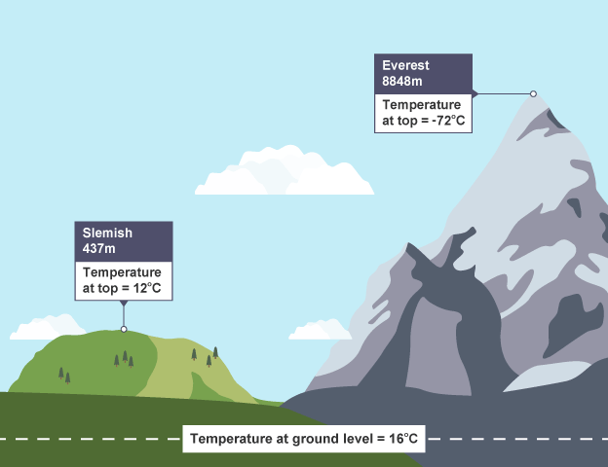

## 2.The influence of relief

Relief is the general appearance of the land of the land surface.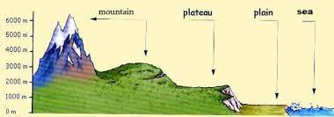

Africa has a varied relief ranging from plains to high mountains all these have influence on the climate of Africa as follows:

* Flat areas experience dry weather conditions because there are hardly any hills or mountains which could hold back winds.

As a result, the winds gather speed over such areas and drive away clouds to other areas.

* 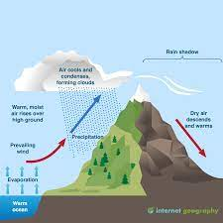Highland areas like Ethiopian highlands, Cameroon highland and Atlas receive heavy rainfall due to the fact that the incoming winds are forced to rise when the blow towards the highlands and in the process cool, and the moisture condenses into orographic rainfall on the wind ward side.

The leeward side is however in the rain shadow and they have arid/dry conditions as illustrated below; illustration of the relief rainfall

## 3.Latitude:

The latitudinal position of Africa explains the tropical nature of climate generally characterized by hot temperatures since the sun is normally over head the tropics that is the sun migrates within the tropics. This is because the concentration of the sun rays is greater within the tropical region.

Places near the equator experience maximum heat from the sun and therefore, experiencing warm to hot temperatures all the year except in hilly areas.

The warm to hot temperatures lead to high moisture content in the atmosphere which results into high precipitation with two peaks of rainfall or bimodal rainfall.

Areas far away from the equator have one rainy season followed by a long dry season.

## 4.Wind systems:

Africa is placed in the global context of winds.

The most influencing ones on her climates are the:

North east, south east and south west prevailing/trade winds.

Generally, the low-pressure trough that develops over Africa in the tropics attracts winds from centres of high pressure usually over the cooler water bodies. The winds are drawn in into the trough and converge over the tropical lands and causes convectional rainfall over many places in Africa.

sketch map of Africa showing the trade winds that affect climate.

At the front of the winds heavy rainfall develops and falls as convectional rain. The winds blowing from ocean surfaces pick moisture from the water and deposit it over the surface of the continents.

This explains why much of West African coast is wet.

However, some of these trade winds are dry especially when they passed over the continents or highlands which rob them of the winds.

Examples are the Harmattan trade winds in West Africa and the northeast trades over Ethiopian highlands.

## 5.Ocean currents:

There are two types of ocean currents namely the warm ocean currents and the cold ocean currents. Both affect the climate of Africa.

An ocean current is a circulation in the surface water of oceans kept in motion by prevailing wind but their direction is altered by the rotation of the earth

### The warm currents :nutritious

They are warm and have warm temperatures and flow from areas of high temperatures (low pressure)to low temperatures(high pressure)

### Their effect

They carry humidity and are responsible for warming up the coasts they blow and bring cloud cover and lead to the formation of rainfall to the adjacent lands when the winds blow.

### Cold currents: what is that

They are cold and flow from region of lower temperatures to areas of high temperatures and flow from areas of high pressure to lower pressure

### Their effect

They lower the temperature the coast where they blow , and they contribute to the aridity of the coast they flow and they produce fog

## 6.Vegetation cover:

Areas that are covered with extensive, dense and thick forests like in the Democratic Republic of Congo receive heavy rainfall throughout the year because of high rates of evapo- transpiration from the thick leaves of plants.

Areas without vegetation or with scanty vegetation cover are dry.

## 7.Water bodies - lakes:

Some places close to large masses of water bodies experience local climate. For example, through lake and breeze processes the temperatures and rainfall of adjacent lands bring about special climate conditions.

A lake breeze is a blow of wind from the water surface to the land to replace a rising warmer air. Such winds blow during the day when the temperatures over the land become higher than those over the water surface. The lake breezes impregnate the air with moisture for usually heavy afternoon rains.

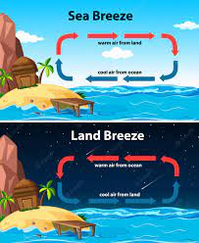During the night when temperatures fall, the land cools faster than the water and so the pressure over land is high compared to that over the water. A wind from the land blows to the water as a land breeze leading to heavy stormy rain over the water surface and adjacent lands.

## 8.Apparent movement of the overhead sun

The position of the overhead sun influences the moment and subsequent position of the inter Tropical convergence zone (ITCZ is the low-pressure zone of unstable air masses which keep on shifting depending on the position of the overhead sun).

The ITCZ have a great influence on the prevailing winds - North east and south east Trade winds because they are forced to blow into low pressure belt from regions of high pressure. The inter-tropical convergence is responsible for the seasonal pattern of rainfall distribution in many areas of Africa. It influences climate in the following ways;

* At the time when the sun is overhead around the equator in March and September each year, this belt receives intense heat up air and air masses mainly North east and South east trade winds come to replace the rising air.

The convergence of winds along the Equator in March and September causes heavy rainfall which is well distributed throughout the year with two peaks (Bimodal).

* As the sun moves northwards to the Tropic of cancer the rainfall belt also swifts because the air masses are now converging further north of the Equator. The sun is at the tropic of Cancer around June and the northern part of the equator in Africa experiences a rainy season from April up to August.
* The other months of the year experience little or no rainfall.

The highest temperatures occur just before the onset of rainy season in the Northern hemisphere.

* As the sun continues its journey Southwards beyond the Equator, the rain belt also shifts because the convergence of the air masses is somewhere south of the Equator. The sun is apparently overhead at tropic of Capricorn in December. Therefore, areas south of the Equator like Harare in Zimbabwe experience a rainy season from around October to March.

Vegetation in Africa: climate counterpart

Natural vegetation is the vegetation that grown due to natural conditions sand not by man(no plated forests and crops please).

# Types of vegetation

* Equatorial vegetation
* Savanah vegetation
* Mediterranean vegetation
* Desert vegetation
* Semi desert vegetation
* Montane vegetation
* Warm temperate vegetation
* Swamp vegetation
* steepe vegetation

[map]

## equatorial vegetation

this type of vegetation is more developed in areas which experience an equatorial type of climate e.g., Congo basin of DRC

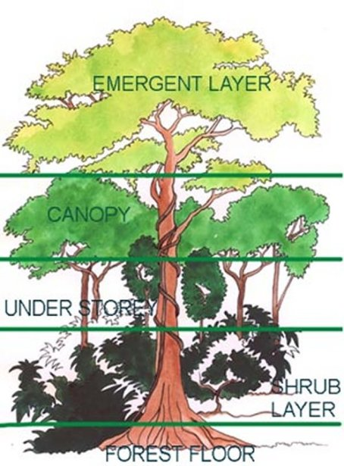

### characteristics of tropical rainforest

* the forests are thick luxuriant e.g., in the DRC the north eastern part of it is covered with forests
* trees are evergreen because they receive heavy rainfall thought the year
* trees have broad leaves to quicken transpiration and photosynthesis
* tropical rainfall forests appear in mixed stand (they have a variety of trees)
* the trees are of hard wood type e.g., ebony mahogany teak sapele mvule
* the trees take a lot f time to mature e.g., 50 years
* trees grow too an average height of 50 m high to get sunlight and have smooth trunks e.g., mahogany
* they form three layers of canopies (trees at an average height)
* they have little or no undergrowth because the try to grow tall to get sunlight
* trees have strong thick buttress root systems so as to support their height

### factors that affect this vegetation

* heavy rainfall over 1500 m per annum which provides water and promotes the growth of luxurious forests
* well distributed rainfall that keeps the vegetation evergreen at all times in a year
* well drained deep fertile soils like laterites and the rich loam soil which support the size and height of the trees
* low altitude which ensures that there are hot temperatures thought the year
* latitudinal location along the equator with in their tropic which brings along the other factors that positively affect the forests
* favourable government policies that safeguard them
* remoteness of these forests that ensures their existence and protect them from human interference

### influence of these forests on human activities

* they help to form rainfall that promote farming and related activities
* forestry and limbering due to the large unexploited resource
* industries have developed due to the raw materials that are there
* tourism due to the animals that reside in this vegetation
* gathering of food from the forests by the tribes in the forests
* hunting of wild animals for food and skins

## 2. savannah vegetation

this type of vegetation refers to a large of communities that lie in between the tropical zone and the desert zone land this climate is in sync with the savannah climate

the rainfall in them differs as there are types of the vegetation e.g., the savannah grassland, savannah woodland and dry savannah

savannah woodlands  
this type of vegetation is in areas that near the tropical rainforests where there is a high amount of rainfall and the dry season is short and its also called tropical woodland

it is found in the central parts of Nigeria, Benin, Togo, Ghana, ivory coast and the guinea north of the tropical rainforests and the south of the Congo basin in the countries of Zambia and Botswana and Angola.

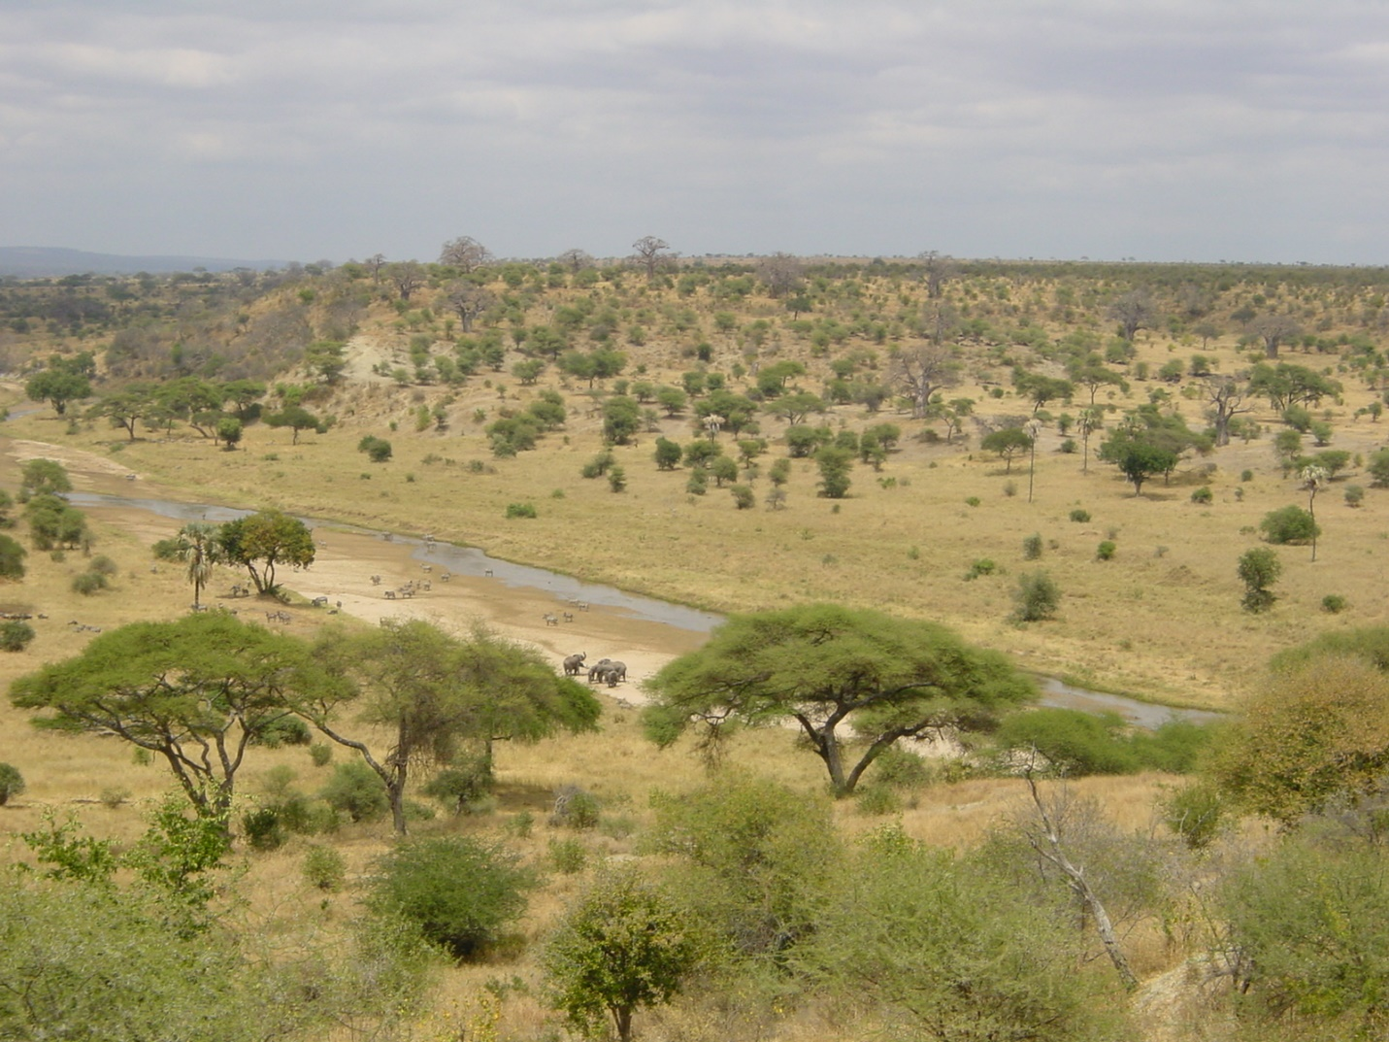

#### Characteristics of this type of climate

* the woodlands are characterized by short trees with a staggering height of 8-16 m and grow over a wide area
* the trees are umbrella shaped at the top like acacia tree
* the trees are deciduous and they shed their leaves during the dry season
* the trees have short trees and dense grasses and bushes growing between them
* these trees are drought resistant e.g., acacia
* tress have deep tap roots to reach underground water resources
* the vegetation is green during the wet season and brown during the dry season
* the trees mostly have hard wood trees
* they have swollen trees to store water during the dry season

#### conditions that support the savannah woodland

* moderate rainfall ranging from 800 to 1500 mm per annum which favours some of the wood species
* hot temperatures of 230c which favours quick growth of woodlands
* the seasonal rainfall which results into alternating green and brown colors
* fertile soils with low water retention capacity which results to the growth of water retention crops
* low lying relief which ensures that hot temperatures
* human activities that have inversely affected the forests
* limited surface drainage which results to the growth o f shrubs
* pests that scare away and settlements like in miombo woodlands
* the short dry season and the long-wet season which supports growth of trees and shrubs
* high humidity during the rain season that results to green season and the low humidity during the dry season that results to brown cover

### savannah grasslands

the woodlands grade into grasslands where amounts of rainfall decrease and the dry season is longer

the grasslands occur in the north of savannah woodlands like the northern parts of Nigeria and Benin and Togo as well as the southern parts of Africa such as Angola, Botswana, Zimbabwe, Mozambique and south Africa

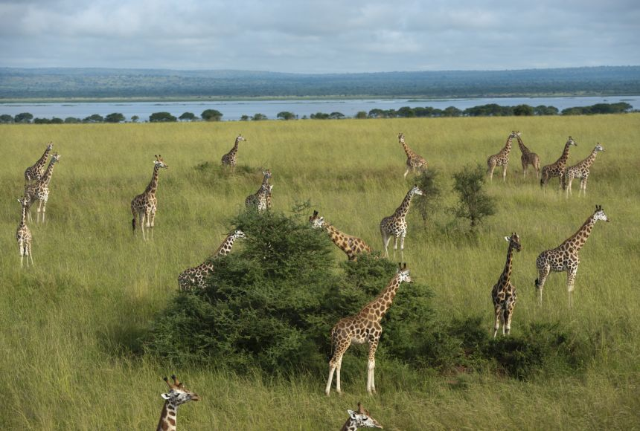

characteristics of savannah grasslands

* the grasslands consist of mainly grasses like the elephant and the spear grass
* the grass ranges from 1 to 3 meters
* the grasses wither and dry up during the dry season forming a brown cover and a green cover in the wet season
* the trees are drought resistant and are deciduous in nature
* the have short scattered trees
* deep tap root system and small leaves that reduce transpiration

conditions that favour the growth of the savannah grasslands

* moderate rainfall of 500 to 800 m which supports the growth of tall grasses
* alternating dry and wet seasons that lead to the growth and wilting of the grass
* fairly fertile soils that support the growth of the grass
* low humidity in the atmosphere favourable for the growth of grass and drought resistant trees
* low water content in the soil which favours the growth of tall grasses
* hot temperatures above 250c that leads to the shedding off of their leaves

dry savannah vegetation   
near the desert fringes where the rainfall is less and the dry season and the is long as 5to 9 months and it’s found in areas like Senegal Mali Niger Chad to the Sudan . as the precipitation declines the grass gets shorter and sparser

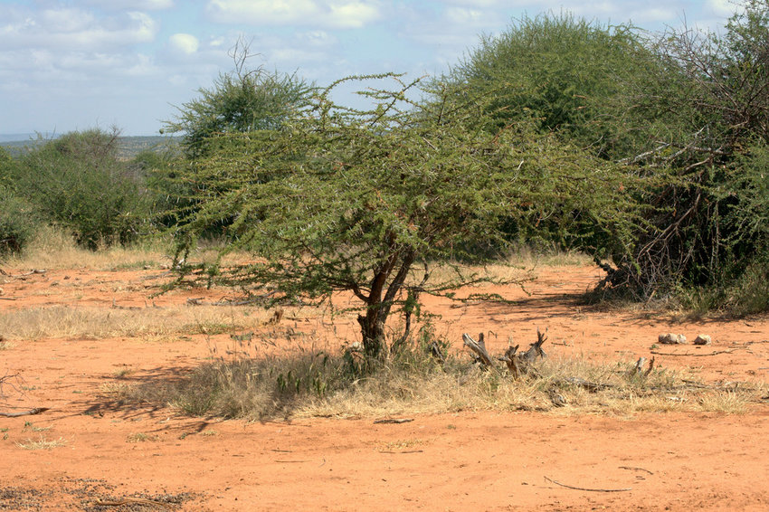the vegetation of this climate is characterized by thorns and short course grass and trees which can with stand drought and other harsh factors.

Characteristics of this dry savannah vegetation

* bushy and thorny trees of 5 to 10 meters tall are densely interlaced with each other and the have shrubs with them
* the grasses are very short and with bare ground between scattered thorny bushes
* the few trees there are drought resistant with very small leaves or thorns to reduce the rate of transpiration the trees are short and stunted
* the trees have long tap roots to reach under ground water
* the threes are drought and fire resistant
* the trees have swollen barks to store food and water during dry season

conditions favouring the growth of savannah vegetation

1. moderate rainfall ranging between 250 to 500 mm per annum which favour the growth of dry savannah vegetation
2. hot temperature of over 260cwhich facilitates the growth of trees with small twisted leaves to avoid loss of water through transpiration
3. low lying relief below 1250 meters above sea level like in the rift valley floor in Ethiopia and Mozambique
4. the leeward side of the mountains like Ethiopia adamawa highlands where there is scarce rain and dry winds favours growth of dry savannah
5. low fertile and sandy soils with limited retention capacity that can support low quality vegetation
6. the long dry season which favors the growth of dry savannah
7. human activities like bush burning and overgrazing which have degrade the vegetation

influence of savannah vegetation on human activities

* the grasses in the savannah provide natural pastures which promote nomadic pastoralism
* the savannah vegetation is used for game rearing and wildlife conservation like Victoria fall national park in Zimbabwe, and queen Elizabeth national park in Uganda
* growing of crops like maize cassava .and plantation farming due to the rainfall received and picking of food
* the woodlands are used for firewood collection and charcoal burning
* bee keeping is also practiced for production of honey
* there is gathering of fruits like shea nuts are collected in west Africa and are used in production of oil for fuel and butter for food

Desert vegetation   
the major areas having vegetation in Africa are the desert Kalahari Sahara and the and namib desert

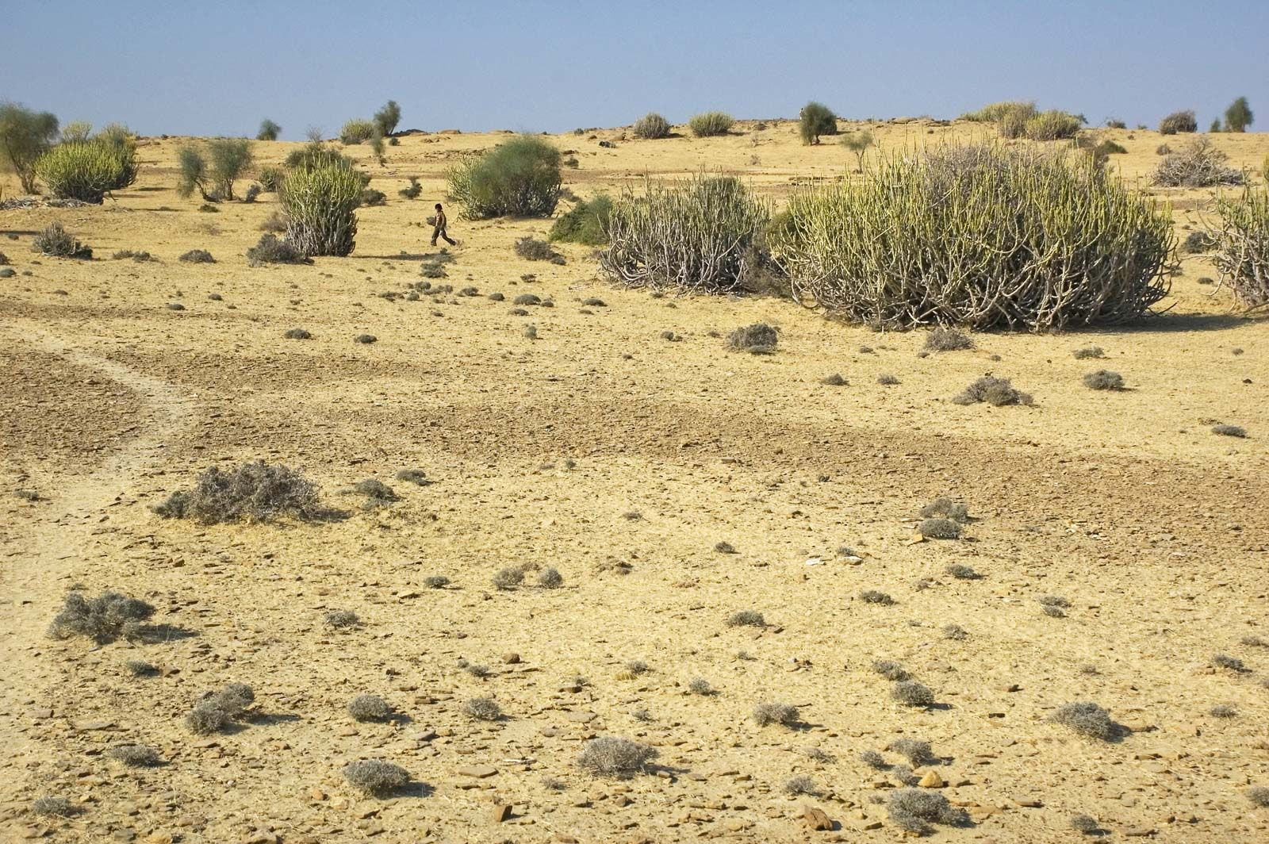

Characteristics of desert vegetation

* the vegetation consists of mainly thorny bushes course grasslands and flowering herbs
* the vegetation is very scanty and most areas are barren
* most of the vegetation occurs near oases at the fringes of the desert
* vegetation is drought resistance like cacti and baobab trees
* many plants have strong deep penetrating roots
* many plants have thick barks to store food
* many plants have tiny leaves which are always waxy to reduce water loss at all
* vegetation has short and tough grasses
* vegetation is very scanty and is found at oases

conditions that favour the growth of desert vegetation

* very low and unreliable rainfall that makes vegetation scanty
* low and unreliable rainfall which results into the growth of drought resistant trees
* very hot temperatures of about 300c which make the vegetation more scarce
* thin soils that result into sparse vegetation
* extremely dry winds which dry the crops and hinder the plant growth

Mediterranean vegetation   
this type of vegetation mainly occurs in south west Africa (cape province)and extreme north parts of Africa {Algeria Tunisia and small parts of Morocco and small parts of Libya

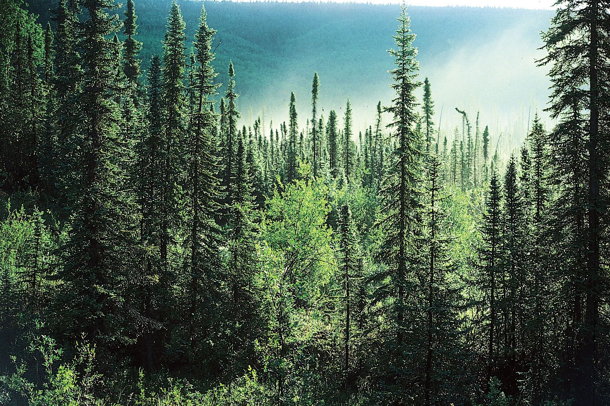

Characteristics of the vegetation

* many of the trees in this vegetation are oak and cedar holm oak cypress giant red wood Aleppo pine
* most plants are thorny in nature with some creeping
* it has sweet smelling plants like rosemary lavender and lyme to attract pollination
* tree species like cedar and oak have large flesh bulbous roots which store large amounts of water for use during summer season
* trees in the dry Mediterranean have waxy leaves to avoid water loss through transpiration
* tree species like eucalyptus have deep tap roots to enable them tap water very deep in the soil
* trees are widely spaced with limited foliage to reduce competition for water
* oak has a very thick bark which reduces transpiration e.g., cork bark which as a very thick oak which cork is made from
* trees are conical shaped and yield soft wood

condition that favours the growth of Mediterranean vegetation

* cool winters that favor the growth of conifers and oak trees
* warm and dry summers which favour growth of shrubs
* moderate rainfall in the regions that favour the growth of trees which are evergreen such as conifers
* fertile alluvial and sedimentary soils which favour the growth of a wide range of coniferous plants
* the variations in the climatic conditions of warm and dry summers as well as cool and wet winters which result into mixed species of plants
* Mediterranean vegetation is drought resistant (xerophytic) so it can survive any type of variation
* favourable government policies of vegetation conservation have prevented the human intervention

economic activities in the Mediterranean

* there is extraction of cork to make cork bottle tops and cork tiles for construction
* collecting of scented plants like rosemary to make perfumes
* lumbering to make furniture
* tourism and wild life conservation because there is habitat for animals
* there is collection of herbs for making medicine

montane /mountain vegetation  
this one is in high land areas and it has different belts and, in each belt, there is a different vegetation for it and this depends on the altitude

the vegetation zones of the mountains

1. 1000 to 1500m Savannah grassland  
   it has savannah like grass though this one is healthy and tall and trees are umbrella shaped and deciduous during dry season the grass turns yellow or brown.  
   towards the leeward slopes there exists poor savannah semi desert scrub characterized by a thicket with   
   stunted trees and a bush
2. 1500 to 1800m savannah woodlands towards rainforest zone   
   it is characterized by drought resistant trees with swollen trunks and cover a wide area and they are deciduous and umbrella shaped
3. 1800 to 2500m tropical rainforest   
   the trees in this one are intermixed and they are close together and there is little or n undergrowth due to the thick layer of canopy. Threes have big buttress roots
4. 2500 to 3200m temperate forest  
   it is characterized by slender and uniform tree species similar those to in the temperate world. These trees yield cones rather than fruits and these trees have straight needles and have straight trunks and get shorter as the rainfall reduces over the height
5. 3200 to 4000 bamboo forest   
   these have segmented hollow stems like sugarcane stems with small tough and needle-sharp leaves. They are evergreen and have prop roots and appear in single layers. They grow in this zone because of low rainfall and temperature
6. 4000 to 4500 heath and moorland   
   this is the last vegetation zone on the mountain ad this one consists of shrubs and grasses like tussock alchemia and lobelia

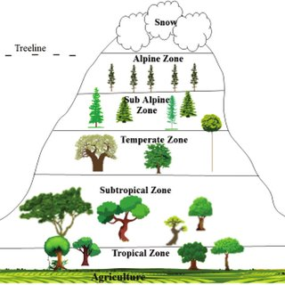

Activities done in this vegetation

* Lumbering
* Alpine grazing
* Tourism
* Farming
* Bee keeping

Temperate grasses /high veld grassland   
this type of vegetation occurs in the continental areas of temperate latitudes. It is found in south Africa in the orange free state and southern Transvaal

Characteristics of high veld climate

* Short grasses
* Few scattered trees in the fringes of the vegetation
* Grasses grow from a short to medium height of 1 to 2 meters
* During dry season the grasses wither to a drab yellow state
* Warm temperate forest in low latitude areas

Mangrove vegetation   
this type of vegetation is located at the east African coast and the west African coast

Characteristics of mangrove vegetation

* Vegetation in this place have aerial roots to hold the tree firmly
* The trees are evergreen
* They have broad leaves to trap sunlight
* Trees grow short trunks ]threes form a close cover

Conditions that favour the growth of the mangrove vegetation

* Hot temperature of 230c that favour the growth of mangrove vegetation
* Low altitude along the cast which favour the growth of mangrove trees
* Shallow marine or salty water
* Heavy rainfall of about 1500 mm which is well distributed
* Deep fertile alluvial soil

Economic activities in mangrove vegetation

* lumbering
* local craft
* farming